**Proof-of-Concept Report:**

**SSL Labs Analyzer & PhishTool**

**Overview**  
This proof-of-concept (PoC) demonstrates how two tools, SSL Labs Analyzer and PhishTool work, and why are they important in SaaS industry.

**Tool Name: SSL Labs Analyser**

**Description:**

SSL Labs Analyzer is an online free tool that scans public web servers to assess their SSL/TLS configurations and security. It provides security grading, and highlights vulnerabilities, and offers practical recommendations for improving transport-layer porotection.

**Why use this tool?**

We should use SSL Labs Analyzer to easily identify SSL/TLS vulnerabilities and misconfigurations in our web servers, ensuring industry-standard encryption and compliance.

**Key Characteristics:**

* Free, web-based SSL/TLS scanner
* Provides A+ to F security grading
* Detects protocol and cipher suite support
* Highlights certificate chain issues
* Identifies deprecated or insecure configurations
* Presents detailed vulnerability analysis
* Offers remediation recommendations
* Supports API and command-line integration
* Requires no installation or local setup
* Generates shareable technical reports

**How SSL Labs Analyzer Supports Cyber Security Officials**

* Rapidly identifies SSL/TLS weaknesses across public-facing servers, helping prevent data breaches and protocol exploits.
* Delivers an easily understandable security grade, making it simple to prioritize remediation efforts and communicate risk to non-technical stakeholders.
* Offers detailed technical findings and actionable recommendations, streamlining the patching of vulnerabilities and strengthening compliance posture.
* Supports integration with security automation tools via its API and CLI, enabling continuous monitoring within modern SecOps workflows.
* Facilitates audit readiness by generating shareable reports that document encryption status and risk mitigation actions.

**How to use SSL Labs Analyzer?**

**1. Go to the SSL Labs Analyzer Website**

* Visit the SSL Labs Server Test page at: <https://www.ssllabs.com/ssltest>

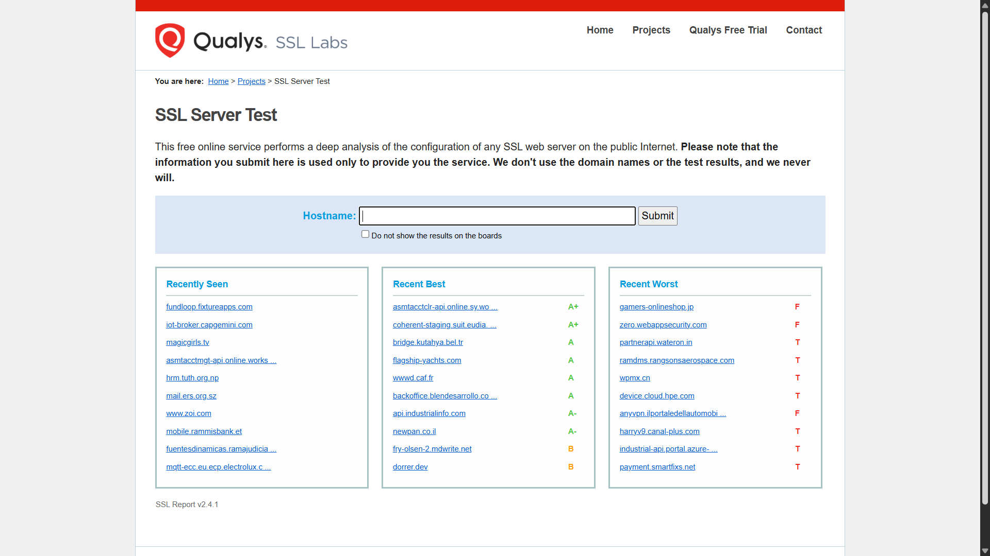

**2. Enter Your Website Address**

* In the "Hostname" field, type the domain name of the website you want to check (for example, example.com).

**3. Start the Test**

* Click the “Submit” button.
* The analyser will start scanning your website’s SSL/TLS settings.

**4. Wait for the Results**

* The scan takes a few minutes.
* You can see a progress bar and messages as the test runs.

**5. Review the Report**

* When finished, you’ll see a summary grade (like A+, A, B, etc.).

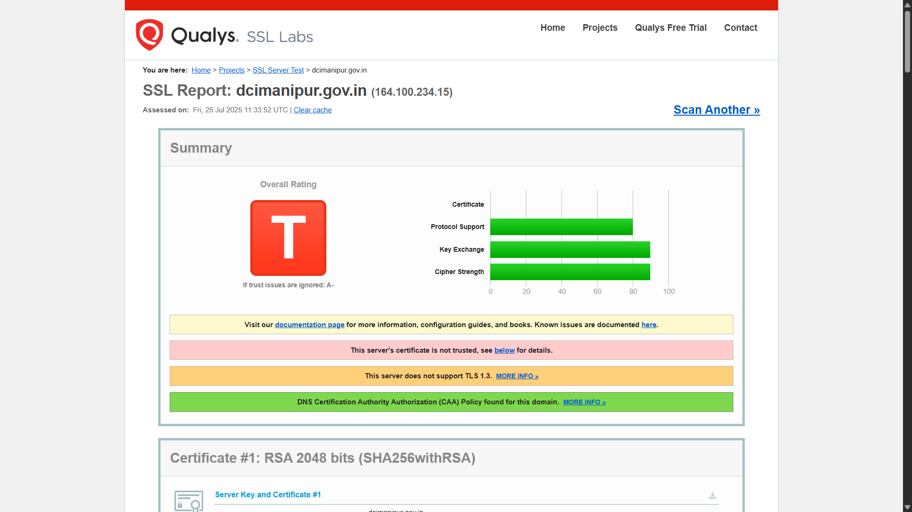

* Check the details below for:
  + Supported SSL/TLS versions
  + Cipher suites (encryption methods)
  + Certificate status (valid, expired, trusted, etc.)
  + Vulnerabilities or weak settings

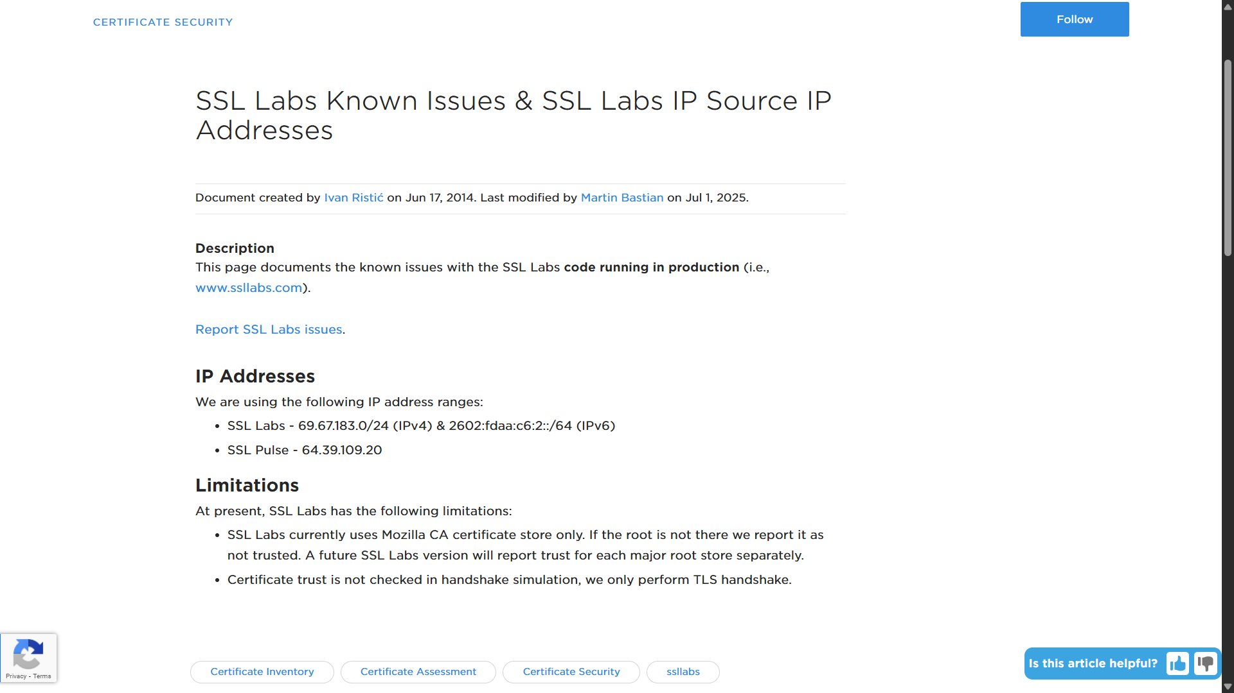

This link can be referred to for the known issues that might exist: [click me](https://success.qualys.com/discussions/s/article/000005823?_ga=2.147454004.2035349400.1753437034-1205775486.1753437034)

**6. Use the Recommendations**

* Issues will be highlighted in the results.
* Read the suggestions for how to fix problems (like disabling old protocols or updating certificates).

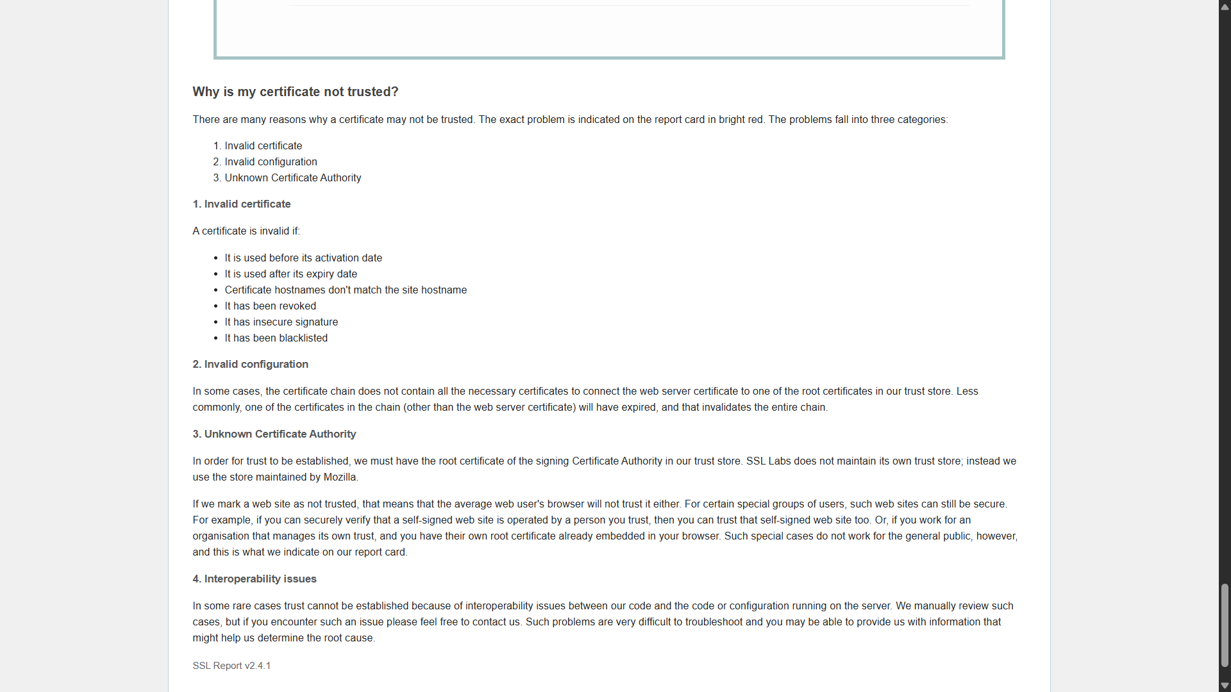

**7. Save or Share the Report**

* You can bookmark the results or download a PDF for future reference or sharing with your team.

**When Should We Use SSL Labs Analyzer?**

* **After Configuring or Updating SSL/TLS Settings:** Run a scan whenever we deploy a new web server, update certificates, or change encryption settings.
* **During Regular Security Audits:** Integrate as part of scheduled security reviews to ensure ongoing compliance and hygiene.
* **Before Launching Public-Facing Services:** Test SSL/TLS for new websites, APIs, or applications prior to going live.
* **When Notified of New Vulnerabilities:** Check proactively when major vulnerabilities (like Heartbleed, ROBOT) are reported.
* **If Compliance Is Required:** Use it to validate settings for standards (e.g., PCI DSS, GDPR, HIPAA) that mandate secure transport.
* **After Remediation:** Rerun tests after fixes to confirm problems (such as weak ciphers or expired certificates) are resolved.

**Who Should Use SSL Labs Analyzer?**

* **Cybersecurity and IT Security Teams:** To assess, monitor, and improve encryption posture of public servers.
* **DevOps and System Administrators:** To validate SSL/TLS configurations during deployment, patching, and maintenance.
* **Compliance and Risk Officers:** To document secure transport-layer configurations for audits and governance.
* **Site Owners and Webmasters:** To quickly check if their websites are secure and trustworthy for users.
* **Penetration Testers and Security Auditors:** As part of vulnerability assessments and reporting for clients.

**Summary Table: Usage Scenarios**

| **Role** | **When to Use** | **Purpose** |
| --- | --- | --- |
| Security Team | Periodic/after changes/vulnerability announcements | Maintain secure configurations |
| Sysadmin/DevOps | After server or certificate updates | Prevent misconfigurations |
| Auditors/Compliance | Before/during audits | Meet regulatory standards |
| Website Owners | Before launch/after fixes | Ensure user trust and safety |
| Pen Testers | During assessments | Document transport-layer weaknesses |

In fact, any web developer can utilize this tool to make their websites secure. And companies should hire cyber security officials to ensure their integrity.

**Advantages**

* **Comprehensive SSL/TLS Testing:** Assesses all major aspects of SSL/TLS implementation, including protocol support, cipher suites, certificate chains, and known vulnerabilities.
* **Actionable Grading:** Provides an easy-to-understand letter grade (A+ to F), making it straightforward to interpret risk and track progress.
* **Free and Web-Based:** No installation or account required; accessible from any browser.
* **Detailed Reports:** Offers in-depth technical breakdowns, remediation advice, and shareable reports suitable for audit and compliance documentation.
* **Automation Support:** Provides APIs and command-line tools for integration into CI/CD and continuous monitoring workflows.
* **Regular Updates:** Maintains tests for emerging vulnerabilities (like Heartbleed, ROBOT), helping organizations stay up to date.
* **Widely Trusted:** Recognized standard referenced in security best practices and compliance audits.

**Flaws and Limitations**

* **External-Only Testing:** Only tests publicly accessible hosts; cannot assess internal servers or environments behind firewalls without temporary public exposure.
* **Surface-Level Automation:** While actionable, the tool identifies issues but doesn't automate remediation or configuration changes.
* **Occasional Test Delays:** High demand can cause scan queues, leading to delays in obtaining results, especially for popular or large domains.
* **Limited Contextual Insight:** The tool identifies technical SSL/TLS weaknesses but does not correlate findings with business risk or real-world threat scenarios.
* **Not a Full Vulnerability Scanner:** SSL Labs focuses solely on transport security; it does not test for web application vulnerabilities, misconfigurations outside SSL/TLS, or broader server security issues.
* **Best for Standard Deployments:** Some results and recommendations may not account for unique, non-default configurations or specialized enterprise needs.
* **Potential False Positives/Negatives:** Certain edge cases or advanced setups (like custom load balancers/proxies) may not be properly interpreted, possibly resulting in errors or incomplete findings.

**Tool Name: PhishTool**

**Description:**

PhishTool is a cloud-based tool that helps cybersecurity teams quickly analyze suspicious emails. It automatically looks inside emails to find signs of phishing, like fake links or harmful attachments, and creates easy-to-understand reports to help stop email attacks faster — all without needing to install anything on your computer.

**Why use this tool?**

We should use PhishTool because it helps quickly find and understand phishing emails to keep our systems safe. It automatically checks emails for fake links and harmful attachments without needing install. This speeds up the response and protects users from email attacks.

**Key Characteristics:**

* Cloud-based phishing email analysis and response platform
* Automates extraction and enrichment of email metadata, headers, attachments, and URLs
* Integrates threat intelligence and OSINT for deep phishing campaign analysis
* Provides detailed forensic reports and IoC (Indicators of Compromise) extraction
* Supports Microsoft 365 and Google Workspace mailbox integration for automated email ingestion
* Enables team collaboration with real-time analysis updates and case management
* Offers browser-based usage with no local installation required
* Includes automated phishing alert processing with classification and prioritization
* Supports integration with third-party APIs and SOAR tools for workflow automation
* Designed to speed up triage, reduce analyst workload, and improve phishing incident response effectiveness

**How PhishTool Helps Cybersecurity Professionals**

* Rapid detection of phishing emails
* Automated extraction of indicators of compromise (IoCs)
* Reduces analyst workload and manual investigation
* Integrates with security tools and workflows
* Supports team collaboration and case management
* Provides detailed forensic reports
* Enables faster incident response and containment
* Enhances threat intelligence with external data sources

**How to Use PhishTool:**

**1. Get Your Suspicious Email Ready**

* Save the suspicious email (usually from your inbox or mail client) as a file—formats like .eml or .msg work best.

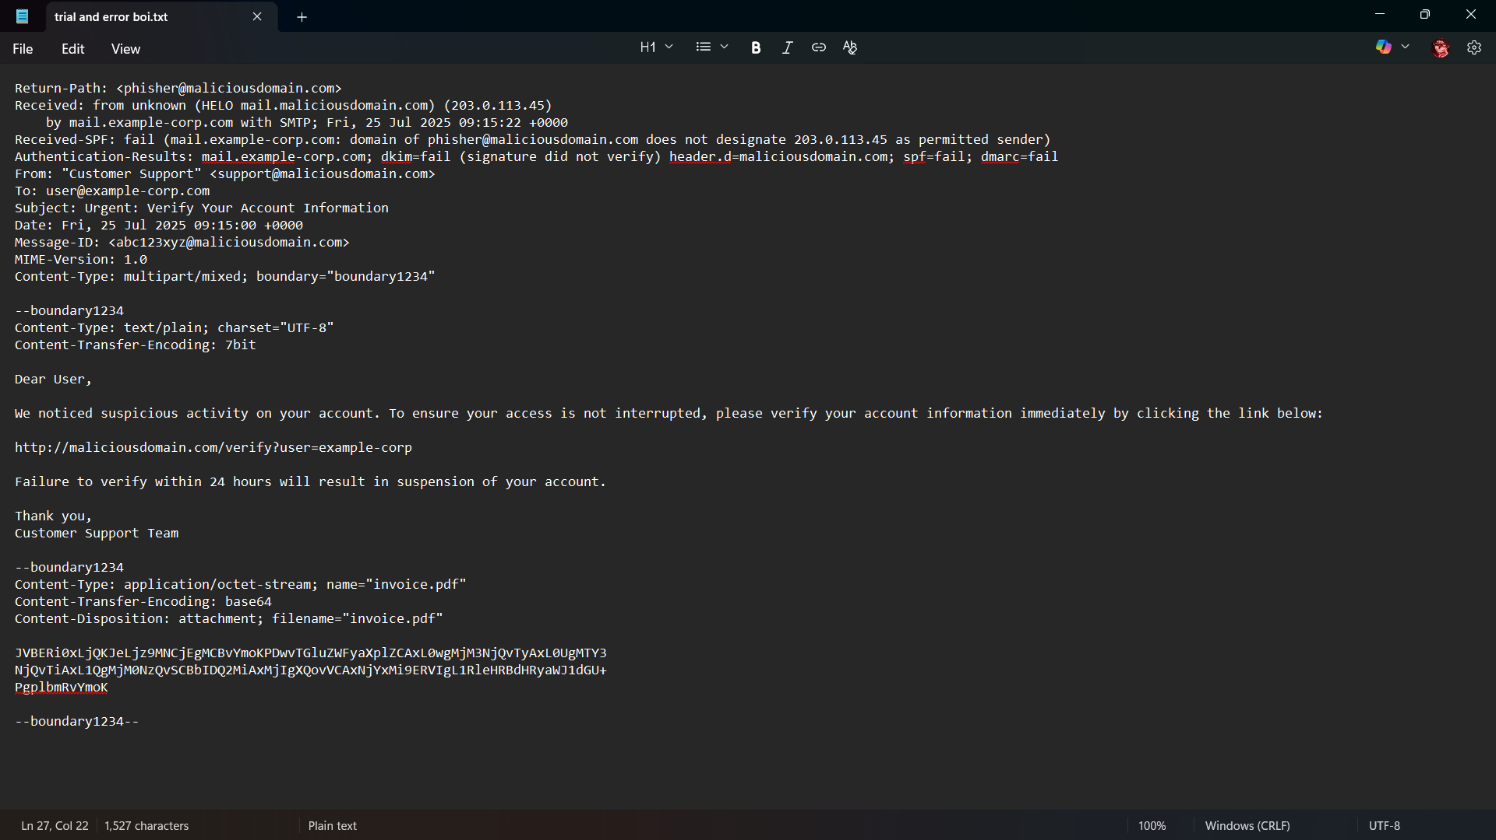

* Make sure the file includes all parts of the email: headers, body, and any attachments.

**2. Open PhishTool in Your Browser**

* Go to the PhishTool website.
* Log in with your account if needed—no installation is required because it's all cloud-based.

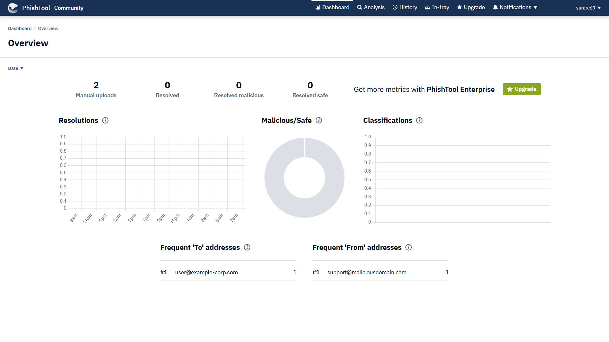

**3. Upload the Email for Analysis**

* Find the section or button labelled "Submit" or "Upload Email."
* Drag and drop the email file or click to browse and select it from your computer.

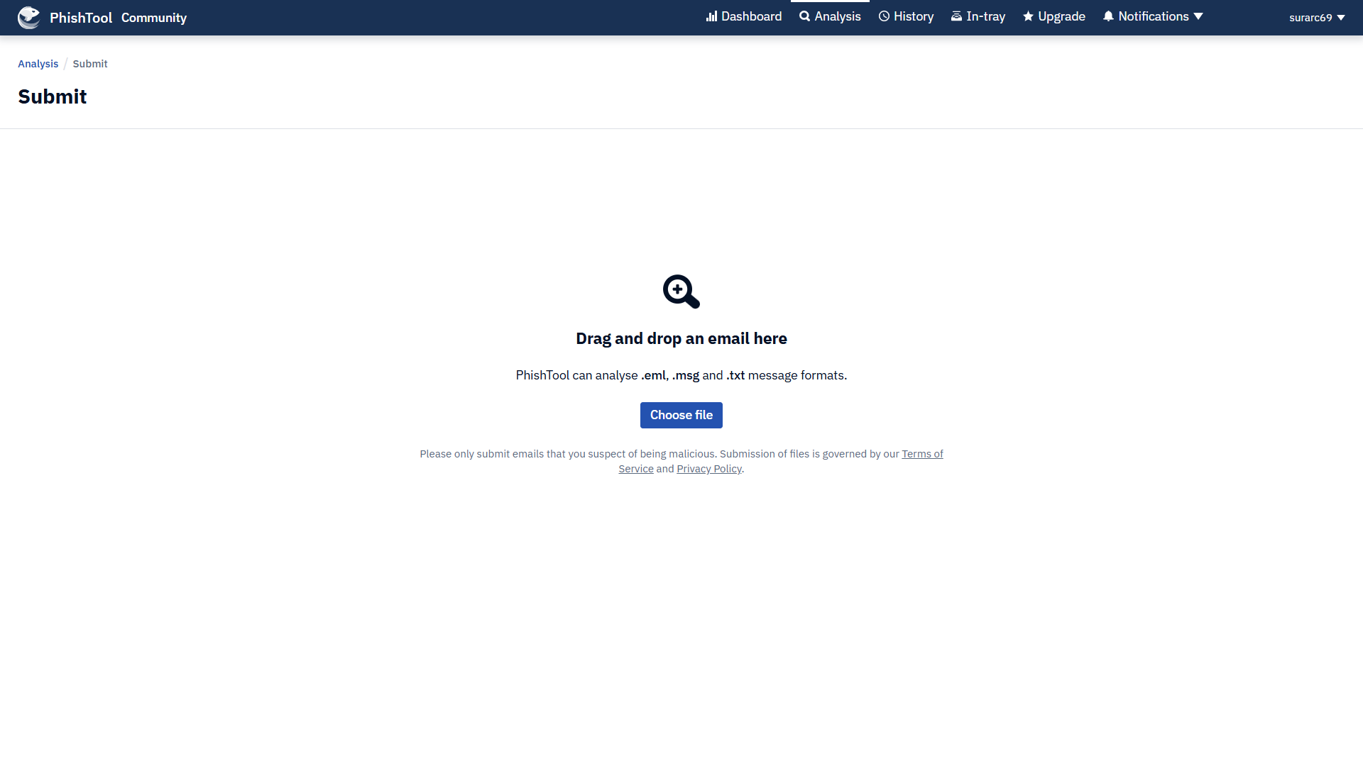

**4. Let PhishTool Analyse the Email**

* The platform will quickly scan the uploaded email.
* It checks for fake links, suspicious attachments, spoofed addresses, and failed security checks.

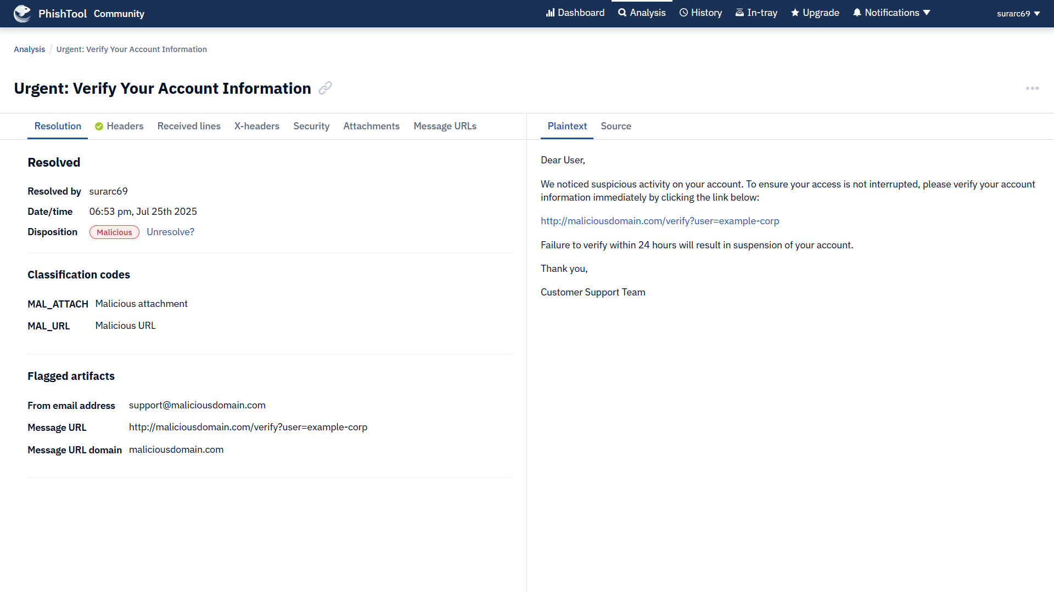

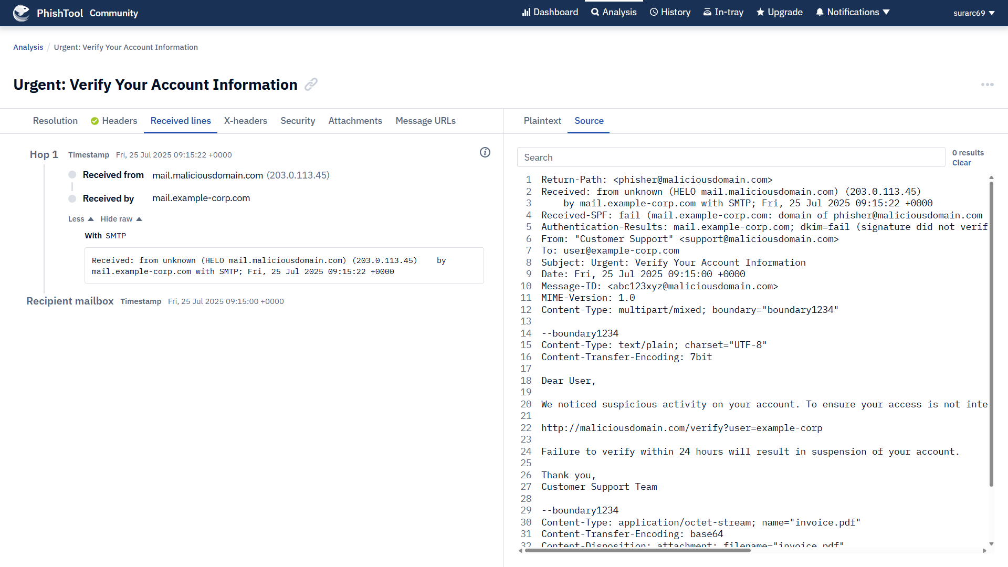

**5. Review the Results**

* You’ll see a summary page showing if the email is safe, suspicious, or malicious.
* Look at the key details: flagged links, domains, malicious attachments, or any email authentication failures (like SPF/DKIM/DMARC).

**6. Take Action Based on the Findings**

* If the email is flagged as phishing, use the provided details (malicious link, sender address, etc.) to block threats or alert your IT/security team.
* Export or download the analysis report if you need it for records or compliance.

**7. Repeat as Needed or Batch Upload**

* You can scan more emails by uploading them one by one, or (if your setup allows) connect PhishTool with your company’s mailbox for automatic scanning.

**Tip:**  
All steps happen in your browser—no software to install, and you can use PhishTool from any device connected to the internet. It’s designed for simplicity so anyone in a security or IT role can investigate suspicious emails fast and easily.

**When Should We Use PhishTool?**

* **When we receive a suspicious or strange email:** Anytime we or our team gets an email that looks like it might be a phishing attempt, scam, or contains unusual links or attachments.
* **During regular security checks:** Use PhishTool to scan emails reported by employees or picked up by our mail security system.
* **Before opening unknown attachments or links:** Always check potentially risky emails with PhishTool to avoid accidental infections.
* **After new phishing threats are announced:** If there’s news about a phishing campaign, scan similar emails to stay protected.
* **While investigating security incidents:** Use PhishTool to analyse emails as part of incident response to quickly spot threats.

**Who Should Use PhishTool?**

* **IT and Cybersecurity Teams:** For fast analysis and response to suspicious emails in organizations.
* **Security Operations Center (SOC) analysts:** To automate phishing investigation, reduce manual work, and improve detection.
* **System administrators:** To validate user-reported suspicious emails and stop possible breaches.
* **Any employee or user:** Anyone unsure about an email’s safety can use PhishTool to get a quick verdict (if permitted in your company).

**Advantages**

* Quickly analyses suspicious emails for phishing threats
* Automates detection of malicious links, attachments, and fake senders
* Easy to use—cloud-based with no installation needed
* Integrates with Microsoft 365, Google Workspace, and threat intelligence sources
* Provides detailed forensic reports and indicators for blocking threats
* Reduces manual work for security teams
* Speeds up response to phishing incidents
* Helps teams collaborate on investigations

**Flaws**

* Only works with emails you can upload—doesn’t automatically scan all inboxes unless integrated
* Requires an internet connection (cloud-based; not usable offline)
* May miss very new or highly advanced phishing tricks if threat intelligence isn’t updated
* Some features (bulk analysis, advanced integrations) may need paid version
* Not a full security suite—focuses mainly on email analysis, not full endpoint protection
* Occasional false positive or false negative results, like all automated tools

In conclusion, both SSL Labs Analyzer and PhishTool are powerful allies for anyone striving to be a better cybersecurity researcher. By using SSL Labs Analyzer, we can easily spot weaknesses in how websites protect information in transit—helping us learn what strong, modern encryption should look like and how to fix common mistakes. PhishTool, on the other hand, gives us hands-on practice with real phishing emails, letting us quickly dissect suspicious messages, find hidden threats, and see exactly how attackers try to trick users. Together, these tools sharpen our ability to think like both a defender and an investigator: they teach us where security gaps often appear, encourage critical analysis, and give us practical ways to improve the digital defences of any organization. In short, they make us smarter, faster, and more effective at protecting people and data in today’s digital world.

**Date:** 25th July 2025

**Author:** Adwitya Deep Verma

**Purpose:** Assignment as an intern at Digisuraksha Parhari Foundation.